1. What type of bond is formed when lithium and fluorine react?

Atomic number (Li= 3 F = 9) Explain (2mks)

2. When solid magnesium carbonate was added to solution of hydrogen chloride in methyl benzene, there was no apparent reaction on addition of water to the resulting solution/ mixture, there was vigorous effervescence. Explain these observations (2mks)

3. Compound “Q” is a solid with a giant ionic structure. What forms would the compound conduct an electric current? Explain (2mks)

4. The melting point of phosphorous trichloride is 900 C while that of magnesium chloride is 7150C in terms of structures and bonding. Explain the differences in their melting points. (3mks)

5. Name one property of neon that makes it possible to be used in electric lamps.(1mk)

6. With reference to iodine distinguish between covalent bonds and van der waals forces(2mks)

14. The table below gives some information about electrical conductivity and likely bonding in substances N, P and Q. Complete the table by inserting the missing information in spaces numbered I, II, and III (3mks)

|  |  |  |
| --- | --- | --- |
| Substances | Likely type of bonding | Electric conductivity  Molten Solid |
| N | Metallic | I Conduct |
| P | II | Does not conduct Conduct |
| Q | III | Do not conduct Does not conduct |

15.

a) What is meant by heat of vaporization? (1mk)

b) The boiling points of ethanol, propanal and butanol are 780C, 97.2oC and

1170C. Explain this trend. (1mk)

16. Use dot (.) and crosses (x) to represent electrons, show bonding in the compounds formed when the following elements reacts (Si= 4, Na = 11, Cl = 17)

a) Sodium and chlorine (1mk)

b) Silicon and chlorine (1mk)

17. In terms of structures and bonding explain why graphite is used as a lubricant

(2mks)

18. a) Distinguish between a covalent bond and a co-ordinate bond. (2mks)

b) Draw a diagram to show bonding in ammonium ion.

(N=7) (H=1) (NH+4) (1mk)

19. Explain why the boiling point of ethanol is higher than that of hexane. Relative molecular mass of ethanol is 46 while that of hexane is 86.

20. Both chlorine and iodine are halogens

a) What are halogens? (1mk)

b) In terms of structure and bonding. Explain why the boiling point of chlorine is lower than of iodine. (2mks)

21. The diagram below is a section of a model of the structure of element t.

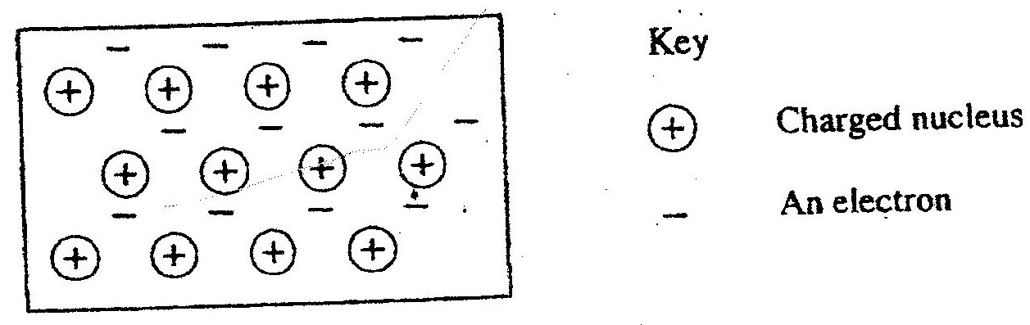

a) State the type of bonding that exists in T. (1mk)

b) In which group of the periodic table does element T belong? Give reason.

22. The table below gives atomic numbers of elements represented by the letters A,

B, C and D

|  |  |  |  |  |
| --- | --- | --- | --- | --- |
| Element | A | B | C | D |
| Atomic number | 15 | 16 | 17 | 20 |

Use the information to answer the questions that follow.

a) Name the type of bonding that exists in the compound formed when A and D react. (1mk)

b) Select the letter which represents the best oxidizing agent. Give a reason for your answer. (2mks)

23.

Study the information to answer the questions that follow. The letters do not represent the actual symbols of the elements.

|  |  |  |
| --- | --- | --- |
| Elements | Atomic number | Melting point (0C) |
| L | 11 | 97.8 |
| M | 13 | 660 |
| N | 14 | 1410 |
| C | 17 | -101 |
| R | 19 | 63.7 |

a) Write the electron arrangement for the ions formed by elements “ M” and “C” (2mks)

b) Select an element which is

i) The most reactive non-metal (1mk)